Opiniano, Ezkylle 03/03/2026
NW – 301 6BLOCKTECH
Finals Lab Activity 3: Additional ERC Tokens
ERC-4626
- known as the Tokenized Vault Standard
- While ERC-20 represents money and ERC-721 represents art, ERC-4626 is designed for yield-bearing vaults.
- It standardizes how users deposit assets (like USDC) into a vault and receive shares in return.
- This is the backbone of modern Decentralized Finance (DeFi) because it allows different apps to talk to each other using the same vault language.
Sample program using ERC-4246
1. Set pragma and semver
2. Open the zeppelin ERC20
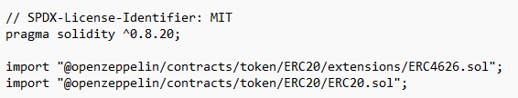
3. Create a contract named SimpleGoldVault align with ERC 4626
4. Create a constructor. The constructor takes the address of the Underlying Asset-->the ERC-20 token)
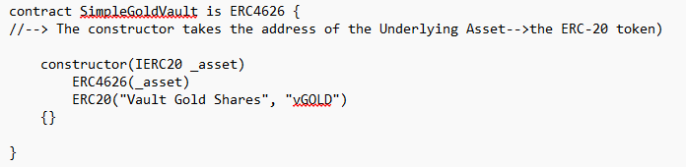
5. Create another contract and constructor for ERC20
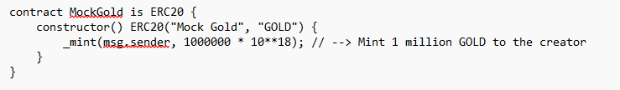
Test the program:
- Compile and Deploy the GoldVault.sol
- Compile and Deploy the MockGold, under the Deploy & Run Transactions, select MockGold and click Deploy. Copy the address of the deployed MockGold contract.
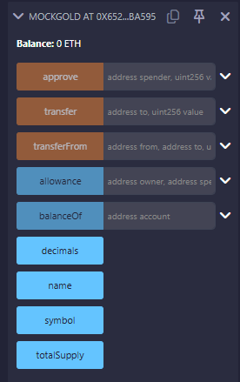
- Deploy SimpleGoldVault, Select SimpleGoldVault and in the Deploy box, paste the MockGold address address you just copied. Click Deploy.
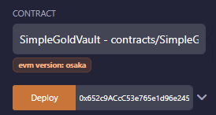
- Transaction:
  - Use MockGold.approve(vaultAddress, 1000) //--> allow the vault to take your gold.
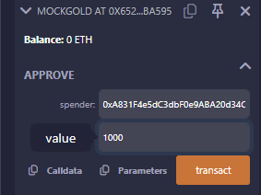
  - Use SimpleGoldVault.deposit(1000, yourAddress) //--> put gold in and get vGold shares.
